Risk Management Report || Group 1

13/03/2020

Created by: Alexa Summers

|  |  |  |  |
| --- | --- | --- | --- |
| Risk | Probability | Size of Loss | Risk Exposure |
| Delay in meetings due to pandemic | Almost Certain | Catastrophic | Extreme risk |
| Developers unfamiliar with tools | Almost Certain | Major | Extreme risk |
| Scheduling estimation failure | Moderate | Minor | Moderate risk |
| No proper UI training | Moderate | Minor | Moderate risk |
| Lack of communication | Unlikely | Minor | Low risk |

Risk response plans:  
  
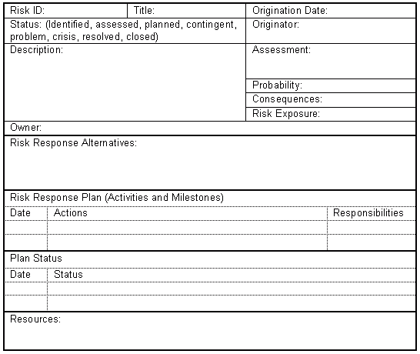

Not applicable—no alternatives other than failure or death

N/A

No resources available

Incomplete – things keep getting worse

14/03/20

Everyone

Schedule re-evaluation

16/03/20

Everyone

Reschedule in-person meetings to online meetings

14/03/20

Alexa

Extreme risk

Loss of time

Almost Certain

New & problematic

A pandemic broke out, and the school shut down. All classes have been virtualized, and no more in-person meetings can be held. Risk of being delayed significantly.

Status: Crisis

13/03/2020

Pandemic

01

29/01/2020

Software Training

02



Various tutorials provided in group Slack channel

15/03/20

Provide coders with further training for project progression—In progress

Provide coders with tutorials -- accomplished

13/02/20

Everyone

Provide coders with further training for project progression

20/03/20

Everyone

Provide coders with tutorials

13/02/20

Learn as we go, designate one person to learn each thing

Tarsus Arciga

Extreme risk

Loss of time

Almost Certain

Problematic

Coders are in need of training in the software being used—no prior experience.

N/A

Status: Planned

Risk response for 01:  
-Meet online  
-Strengthen communication  
-Ask for help from others when behind  
-Adjust schedule to account for falling behind  
-Better prioritize tasks

Risk response for 02:  
-Assign examples for practice  
-Provide more tutorials if needed  
-Designate particular people for specific tasks  
-Adjust software usage